

Standard Operating Procedure (SOP)
Barge Terminal Born

Version: Draft 1.0 – March 2025

- Introduction
Barge Terminal Born is primarily an inland container transport operator and a maritime terminal for deepsea and shortsea containers.
BTB is specialized in taking care of the total logistic operation of the inland container transport for forwarders, carriers and shippers (including Customs facilities)

BTB is situated in Limburg and serving the area between Roermond, Weert, Genk, Liege, Aachen, Düren, Heinsberg and Mönchengladbach.

This document provides insights into our operations, processes, procedures and contact details. In case no deviations are agreed in written, this SOP is applicable to its full extend.

- General information

  - Contact details

Name: Barge Terminal Born
Phone: +31 88 944 0200 (office hours)
Email: bargeterminal@waalhaven-group.nl (booking)
btb.operations@waalahven-group.nl (planning)
btb@waalhaven-group.nl (Gate control)
Website: www.bargeterminalborn.nl
Visiting address office: Holtum-Noordweg 9, 6121 RE Born (NL)
Additional route info: Highway A2 – Exit 46 (Roosteren)

  - Working hours BTB

Truck handling barge terminal | Monday-Friday: 07:00h – 20:45h
Office hours (bookers + planners) | Monday-Friday: 08:00h – 17:00h
Office Gate | Monday Friday: 07:00h – 20:45h
Others | Weekends and national holidays on request and availability. Surcharges apply

Abbreviations
Barge Terminal Born = BTB
Dangerous Goods Area = DGA
Authorized Economic Operator = AEO

2 Truck handling Terminal

2.1 Terminal access
In order to access or visit the terminal, registration is mandatory. The terminal is controlled by Cargo Card. Drivers are required to show proof of identity with their cargo card and proper documents to gain access to the terminals.

Enquiries can be made by sending an email to btb@waalhaven-group.nl

2.2 Booking
A valid and confirmed booking (BTB reference + containernumber) must be made in order to collect or drop a container by truck at our terminal. Bookings can be sent to btb@waalhaven-group.com . Only after confirmation the container can be delivered/picked up. BTB can provide pin code on request.

2.3 Gate in
The truck driver enters the premises, and parks the truck at the designated area before entering the terminal.
The driver can register himself at the front desk.
A valid reference must be presented at the Gate In for the delivery and pick up of (full) container. Without a valid BTB reference a full container can’t be dropped off.
Empty containers, which are known in our system, can be delivered with forwarder name + container number. Depot containers are checked by estimator.

2.4 Front desk
The truck driver reports himself at the counter, handing over the information required and/or ADR/waste documents. The gate employee will verify the ADR-transport document. Failing ADR/IMO stickers may lead to delay, surcharges may apply.

No customs formalities are processed or checked at the counter. Customer and/or driver must always take care of any and all import and export formalities and customs formalities with respect to the container and is responsible to fulfil all obligations resulting out of these formalities.

Interchange document in provided to driver at front desk.

2.5 Gate-in barrier
Turck drivers can only physically enter the terminal if the Gate In process had been completed successfully. The truck driver presents the Cargo Card at the barrier and terminal can be entered. Temporary Cargo Card can be provided against 25 EUR at frontdesk which will give you one time access to our terminal. Payment only by cash.
If the barrier doesn’t work, you can contact the gate desk for further assistance.

2.6 Gate out barrier
The driver presents the Cargo Card to the right barrier and can leave the terminal (one truck per turn). A gate out is registered in the TOS at the moment the Cargo Card is accepted. Interchange will be provided automatically before container move.
3 Order booking

Please make sure your import/export orders send to BTB by EDI or by email to bargeterminal@waalhavengroup.nl Orders need to include following information. Without this information we can’t proceed your order in our system.
After your order is booked BTB will send you the order confirmation.

3.1 Import
Invoice reference
Shipping company
CY | Yes/No
BL number
Vessel + Voyage number
Departure date
Terminal
Quantity (number of containers)
Container type
Container number(s)
Container net weight
Container seal number
Contents
Dangerous goods IMO* | Yes/No
Dangerous goods ADNR* | Yes/No
Dangerous goods net weight* | If applicable
Release number | PCS/PIN
Transit document type
Discharge customer
Discharge address
Discharge date
Discharge time
Empty redelivery depot
Empty redelivery reference
Gas measurement required | Yes/No
Tilt chassis | Yes/No
Remarks

3.2 Export
Invoice reference
CY | Yes/No
Shipping company
Booking number from carrier
Quantity (number of containers)
Container type
Empty pick-up depot
Empty pick-up reference
Release date empty pick-up
Loading adress customer
Loading address
Loading date
Loading time
Loading reference
Dangerous goods IMO* | Yes/No
Dangerous goods ADNR* | Yes/No
Dangerous goods net weight* | If applicable
Vessel + voyage number
Terminal
Delivery reference
Cargo opening date
Cargo opening time
Cargo closing date
Port of discharge
Type of document if known
Document arranged by (name broker)
VGM
Multistop/ weighing
Remarks

4. Barge planning

Request for barge calls during weekdays shall be send latest 7 days before desired timeslot. Confirmation of timeslots at latest 1 day before ETA barge (please see sailing schedule for fixed calls). Acceptance is based on capacity availability.

Request for barge calls during weekends (Saturday 07:00h until Monday 12:00h) shall be send at latest 48 hours before desired timeslot or at latest Thursday 16:00h (earliest moment applies).

Import

Terminal | Fixed call | Data/Cargo closing | ETA Born
RWG | Monday PM | Friday PM | Wednesday AM
Kramer | Wednesday PM | Tuesday AM | Friday AM
ECT/DDE+DDN | Wednesday PM | Tuesday AM | Friday AM
APMII | Thursday PM | Wednesday PM | Saturday AM
Euromax | Thursday PM | Wednesday PM | Saturday AM
Kramer | Saturday AM | Friday AM | Monday AM
ECT/DDE | Saturday PM | Friday AM | Monday AM
BTM | Sunday PM | Friday AM | Tuesday AM
Export

Terminal | Fixed call | Data/Cargo closing | ETD Born
RWG | Monday PM | Friday PM | Saturday PM
Kramer | Wednesday PM | Friday PM | Monday PM
ECT/DDE+DDN | Wednesday PM | Friday PM | Monday PM
APMII | Thursday PM | Monday AM | Wednesday AM
Euromax | Thursday PM | Monday AM | Wednesday AM
Kramer | Saturday AM | Wednesday AM | Friday AM
ECT/DDE | Saturday PM | Wednesday AM | Firiday AM
BTM | Sunday PM | Thursday AM | Saturday AM

Request for barge calls during national holidays need to be send at latest 14 workdays prior to the national holiday. Request is based on availability.

Request of barge timeslot | 7 days before day of arrival deepseavessel
Confirmation of barge timeslot | 1 day before day of arrival
Data/cargo closing – export containers | 48h prior to dispatch
Data/cargo closing – import containers | 24h prior to dispatch

Releases in Portbase/SCR/CPU need to be send in time like configured in table above. Status of bookings/containers can be checked in BTB client portal.
4.1 Sailing schedule BTB
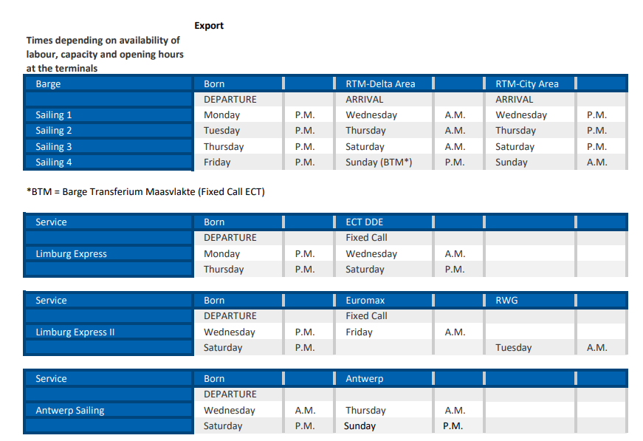

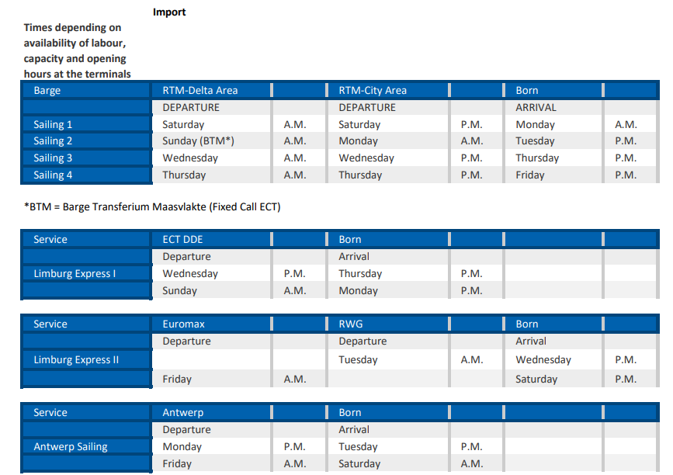

4.2 Available terminals by barge Rotterdam/Antwerp

Available terminals by Barge
Terminals NL |  | Terminal Antwerp
Euromax |  | K188
ECT-DDE +DDN |  | K212
APM2 |  | K364
Kramer-Delta |  | K420
RWG |  | K614
Matrans |  | K730
Moerdijk CCT |  | K869
Hutchinsons Port Delta 2 |  | K913
Kramer City Depot ( KCD ) |  | K1700
UWT-Waalhaven |  | K1718
UWT-Eemhaven |  | K1742
UWT-Friso
Waalhaven Botlek
RST-Noord (Zone10)
RST Zone 8/ 9
Steinweg Beatrixhaven
Cetem Botlek
BCW

5. Storage
Storage of full/empty containers on terminal is overall coordinated by the BTB.

5.1 Full containers
Non – hazardous Cargo
Full containers are stored at our yards according to the AEO regulations. The areas are controlled by fences, camera’s, dogs and barriers.

Hazardous Cargo (ADR/IMO)
At the BTB hazardous goods containers for a max period of 14 days.

Allowed: Not allowed:
IMO Class 1.4 S (except Class 1) IMO Class 1
IMO Class 2 IMO Class 7
IMO Class 3
IMO Class 4.1
IMO Class 4.2
IMO Class 4.3
IMO Class 5.1
IMO Class 5.2 ( on request / limited, organic Peroxide)
IMO Class 6.1
IMO Class 8
IMO Class 9

Hazardous goods labels can be purchased for 5 EUR at the gate-in. Payment only by cash.
On request BTB can send a list of containers present in the storage to customer.

5. 2 Dangerous Goods Area (DGA)
Within the DGA, containers contain hazardous cargo can be stored for a maximum of 14 days. Storage of these containers is subject to availability and subject to limitations concerning UN-number and amount. Customer will be informed when containers reside longer than 14 days on our terminal.
If the customer wished to extend storage we offer the possibility to shunt and store the container elsewhere (depending on classification) until shipping is required. If the customer doesn’t respond to the request for pick-up or extension of storage we withhold the possibility to shunt and store the unit and charge additional costs.

6. Depot, Container Maintenance & Repair

Depot
Empty containers can be stored at BTB. We can automatically send you on regular base a stock overview generated out of our system.

Container Maintenance & Repair
Maintenance and repair of containers is on request.

7. Terminal Services

  - Reefer Containers
Reefers slots are available on request to accommodate storage of live reefers and depending on current availability (will be verified upon order). A request must at least contain the following information:
- Number of reefers and container numbers
- Desired storage duration including ETA and ETD terminal
- Settings

  - Gas Measurement and ventilation
Barge Terminal Born can facilitate gas measurement and ventilation services for third parties. The company of your choice can contact us for further inquiries regarding the conditions.

Order shall be placed directly to the third party and shall be communicated to the front desk of BTB (btb@waalhaven-group.nl). Information should be send 24hrs before container is shipped. If the order is not known 24hrs before ETA surcharges apply to cover additional handling. The order shall at least container the container number and ETD of the container.

  - Electronic Data Interface (EDI)
Upon request a EDI connection can be realized in multiple programming languages to facilitate swift order processing and information exchange.

